Bakery Management API Assignment

1. User Creation/Registration

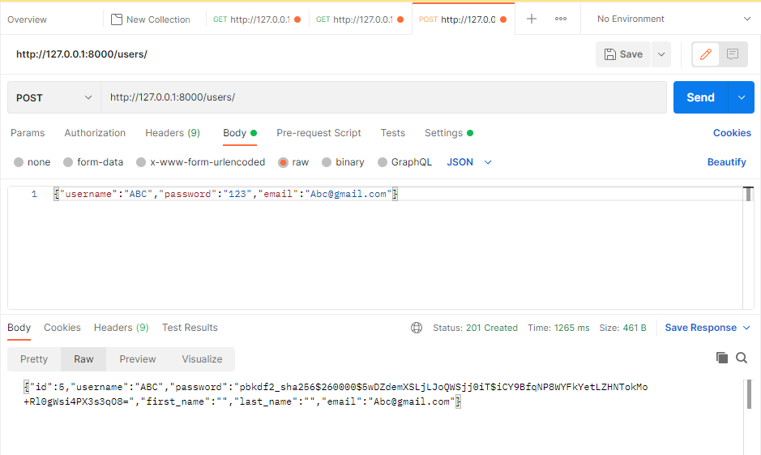

1. Login and creating token

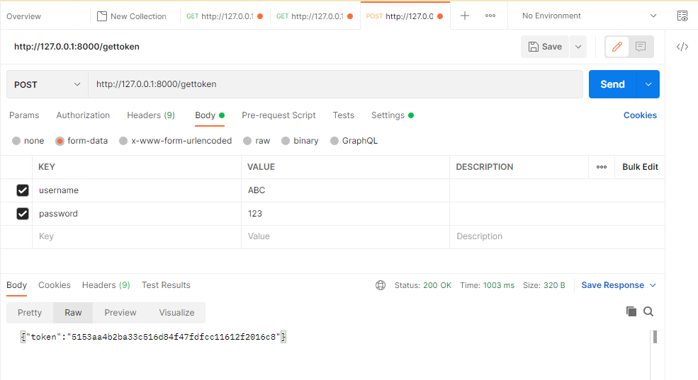

1. Authentication successful to view Bills. Currently bills table is empty.

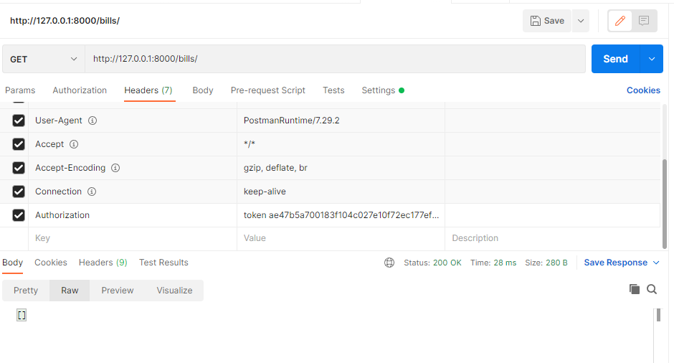

1. Bill Creation

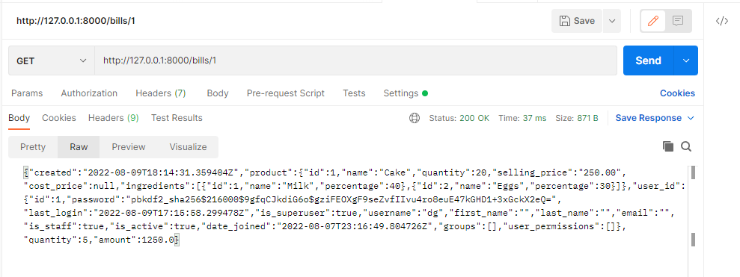

1. Since user: ABC is staff user. Authentication failed for products inventory.

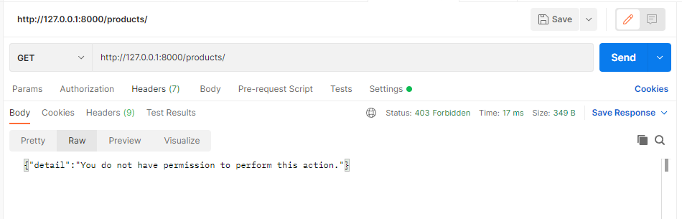

1. Getting owner/superuser/admin.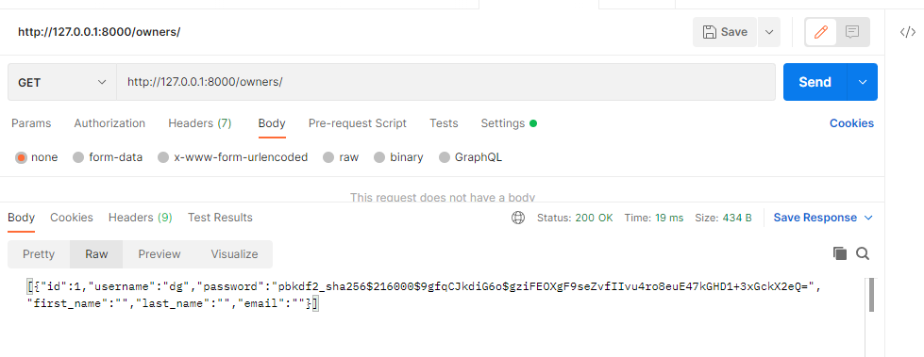
2. Getting token for superuser.

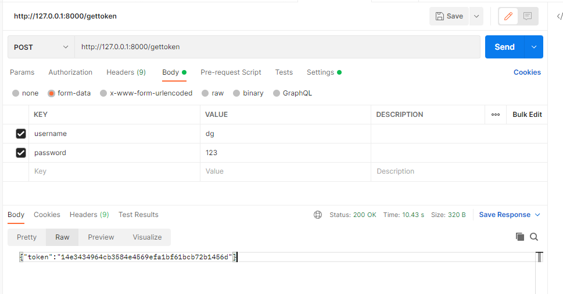

1. Superuser able to access products inventory.

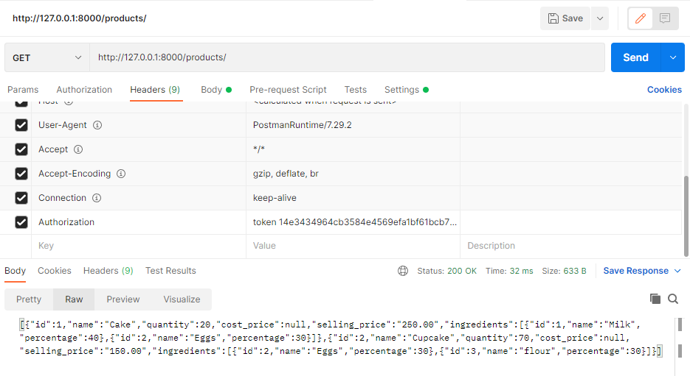

1. Superuser to view detail view of specific product.

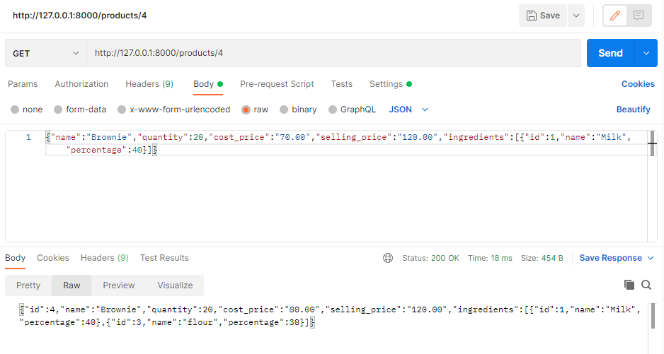

1. Quantity update from 20 to 40

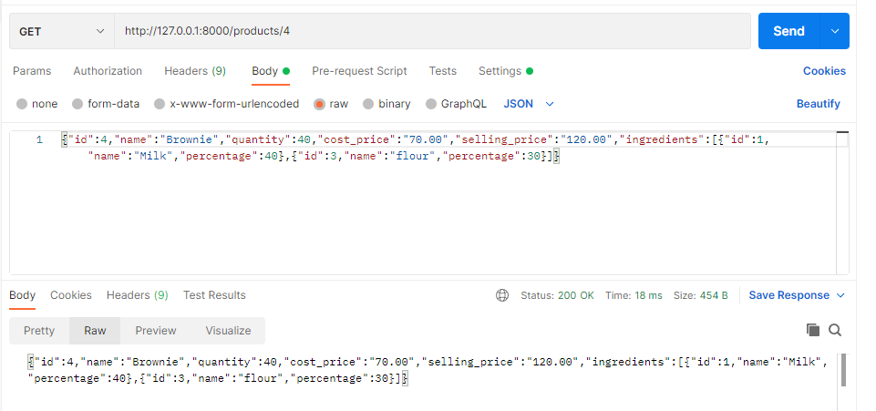

1. Item deleted

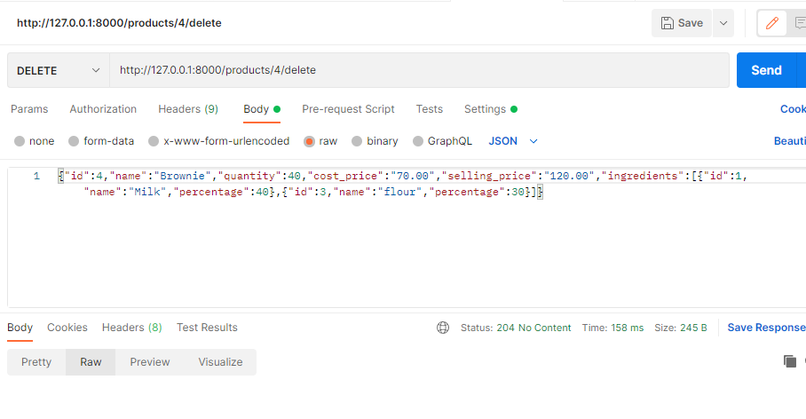

1. Item brownie deleted

